HONORS ASSESSMENT 3

Tithi Agrawal [A14]

Q. Create a facebook like application to store user profile and their social connections, their posts (only text ones for simplicity) and a timeline.

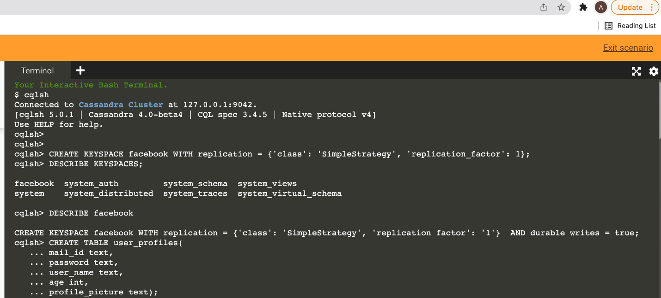

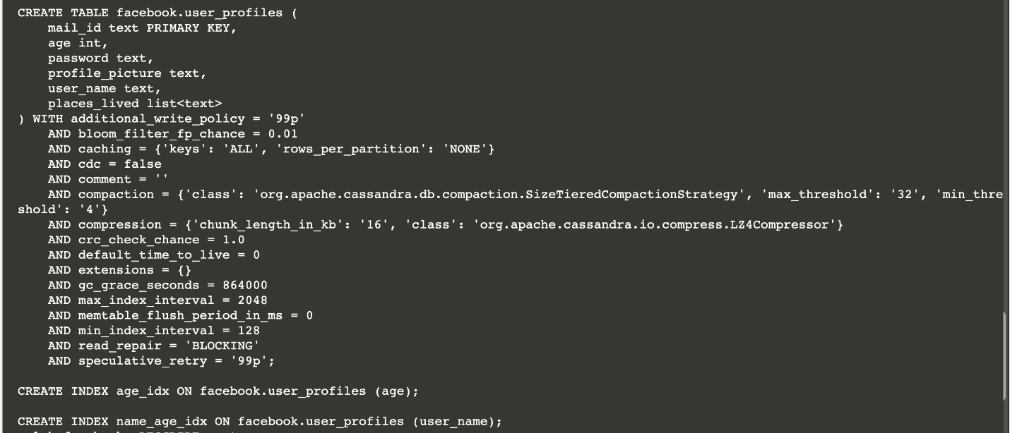

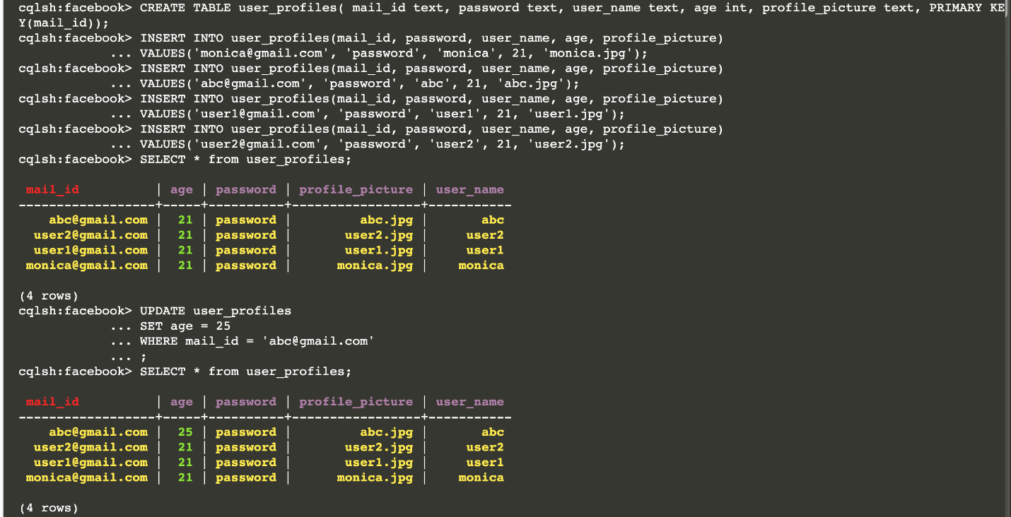

A14 Tithi Agrawal



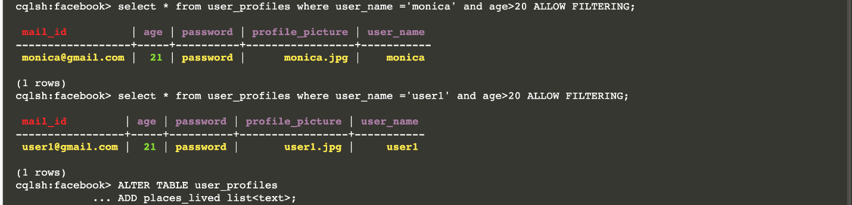

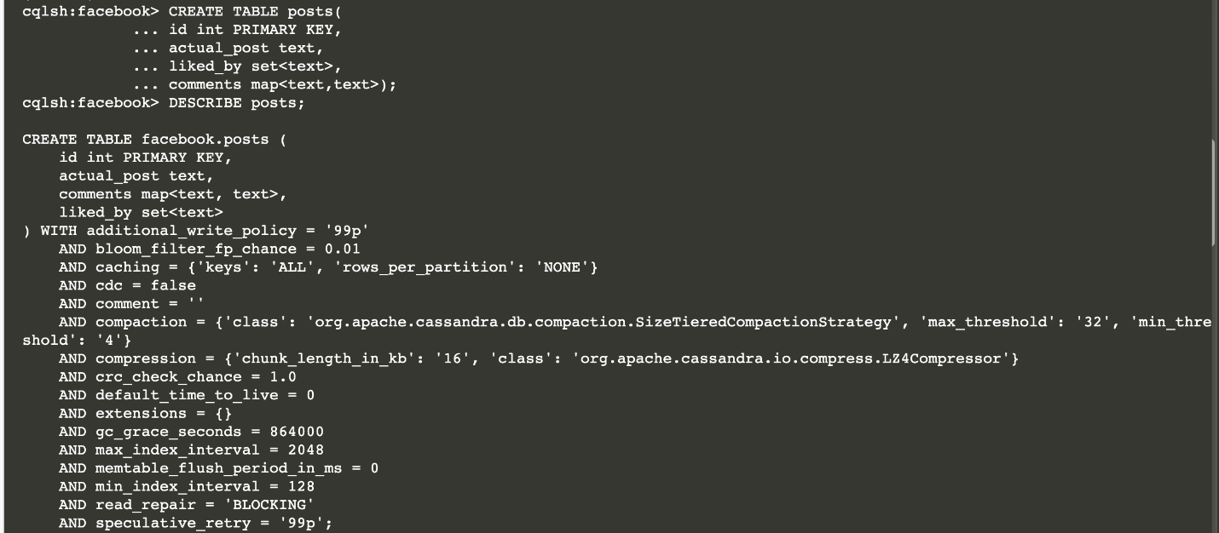

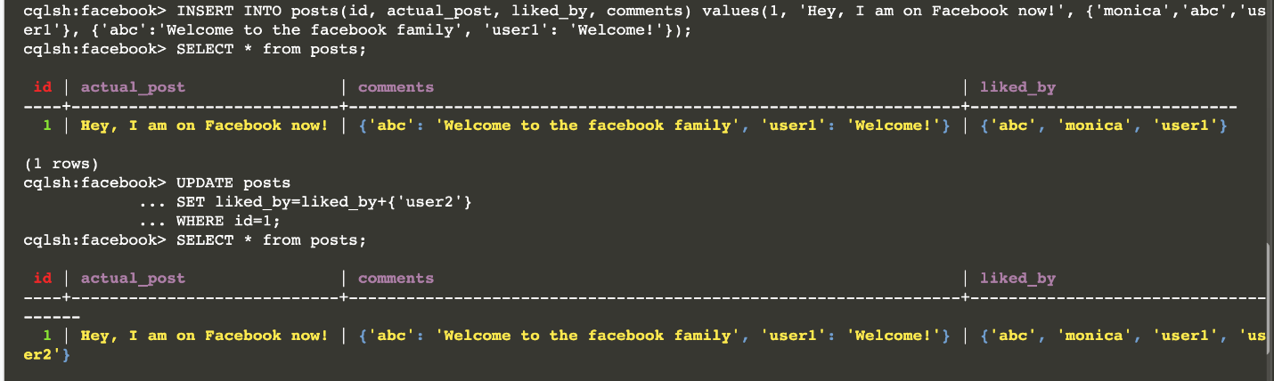



A14 Tithi Agrawal

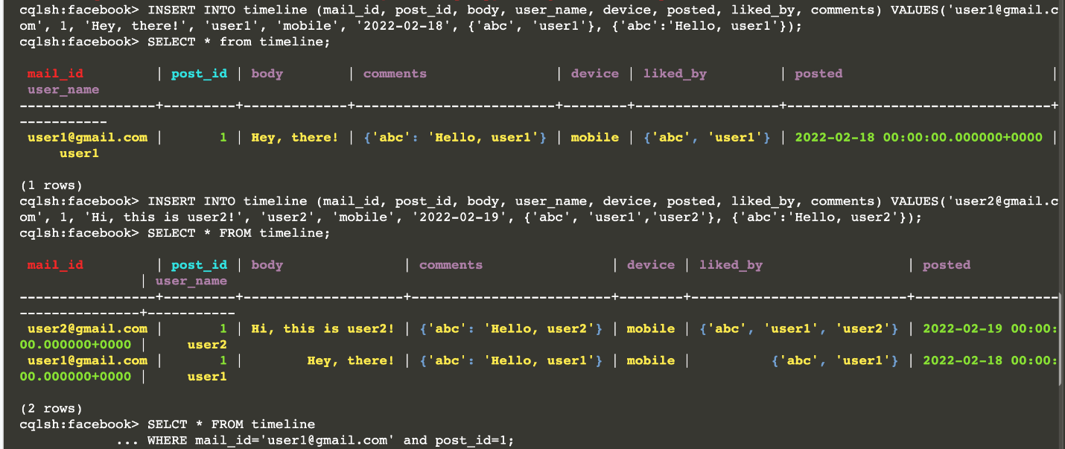

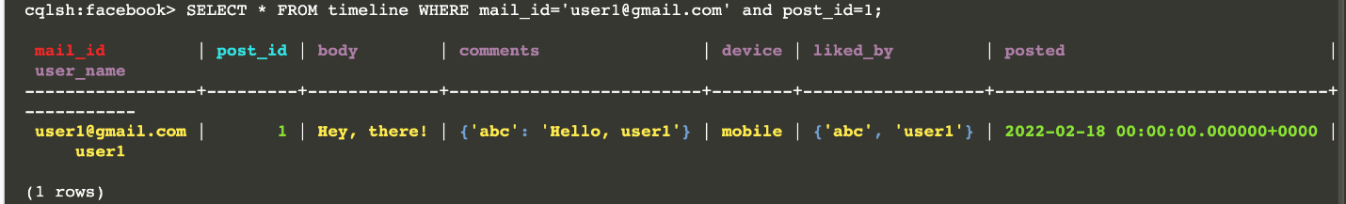

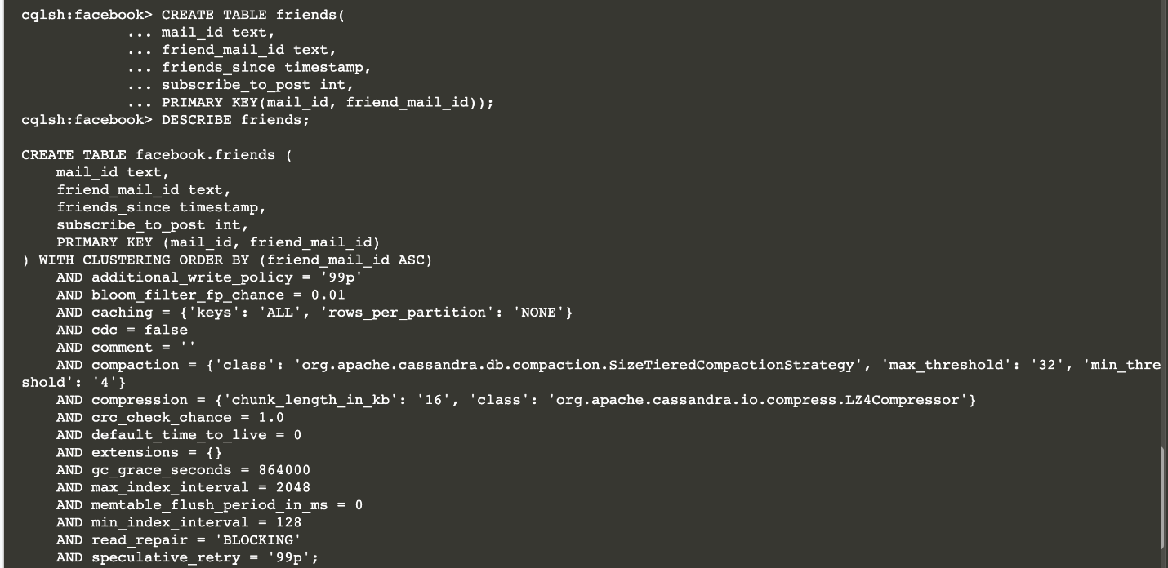

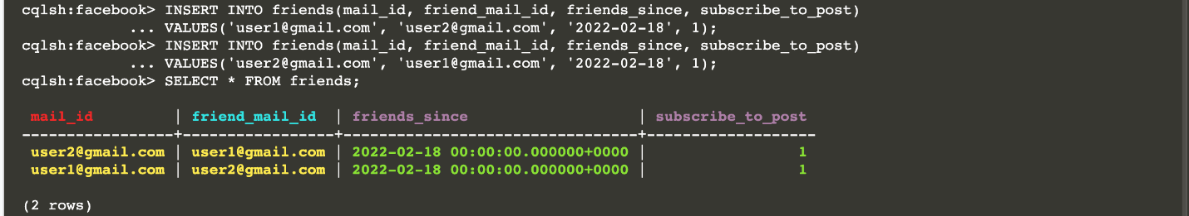

A14 Tithi Agrawal

